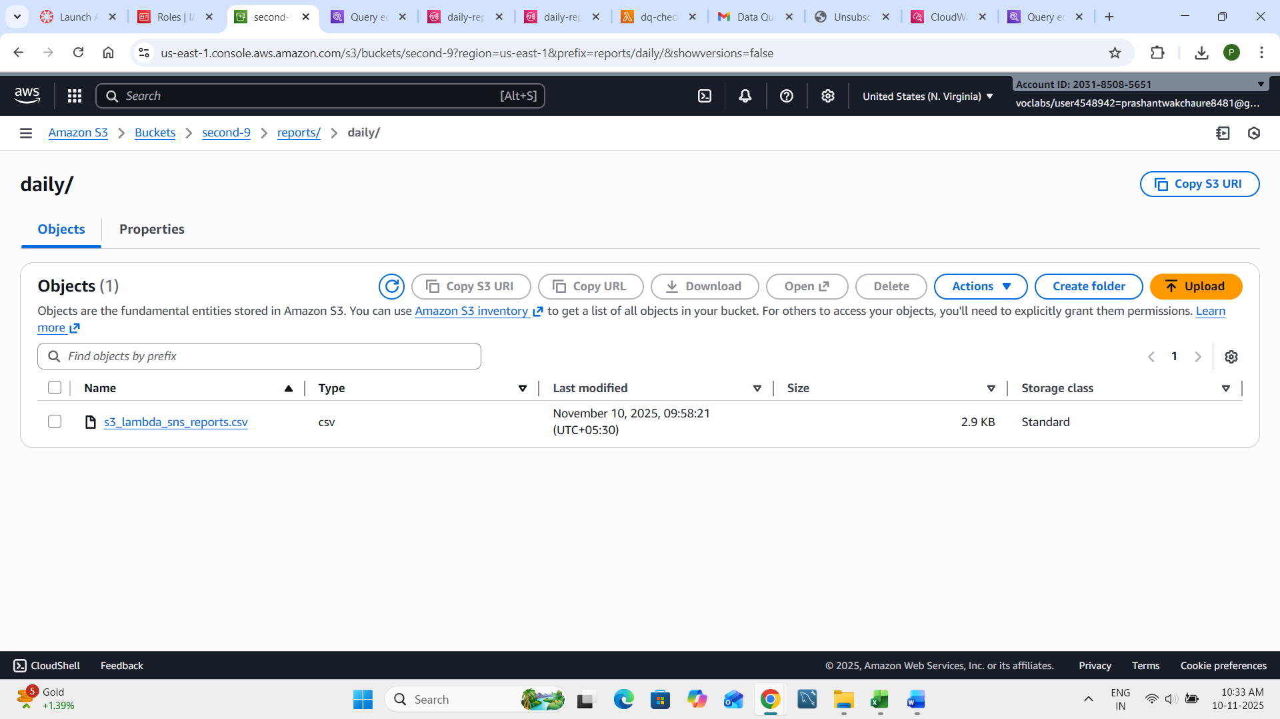

Lamda code-
import boto3
import json

sns = boto3.client('sns')

# 👇 Replace these two values:
SNS_TOPIC_ARN = "arn:aws:sns:us-east-1:203185085651:daily-report-alerts"

def lambda_handler(event, context):
record = event['Records'][0]
bucket = record['s3']['bucket']['name']
key = record['s3']['object']['key']
size = record['s3']['object']['size']
upload_time = record['eventTime']

message = {
"Bucket": bucket,
"FileName": key,
"FileSize": size,
"UploadTime": upload_time
}

# Print to CloudWatch logs
print("File uploaded:", json.dumps(message))

# Send alert to SNS
try:
sns.publish(
TopicArn=SNS_TOPIC_ARN,
Subject="New Daily Sales Report Uploaded",
Message=json.dumps(message, indent=2)
)
print("SNS message sent successfully!")
except Exception as e:
print("Error sending SNS message:", e)

return {"status": "done"}

